**PID CONTROLLER FOR CRUISE CONTROL OF THE CAR**

MASS OF THE CAR: 1000 kg

DRAG COEFFICIENT: 50 Ns/m

SET VALUE: 20 m/s

*The Values I used for Kp, Ki and Kd are:*

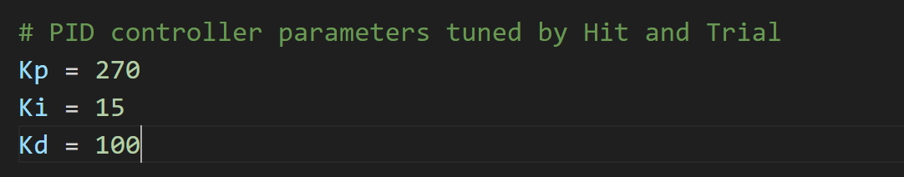

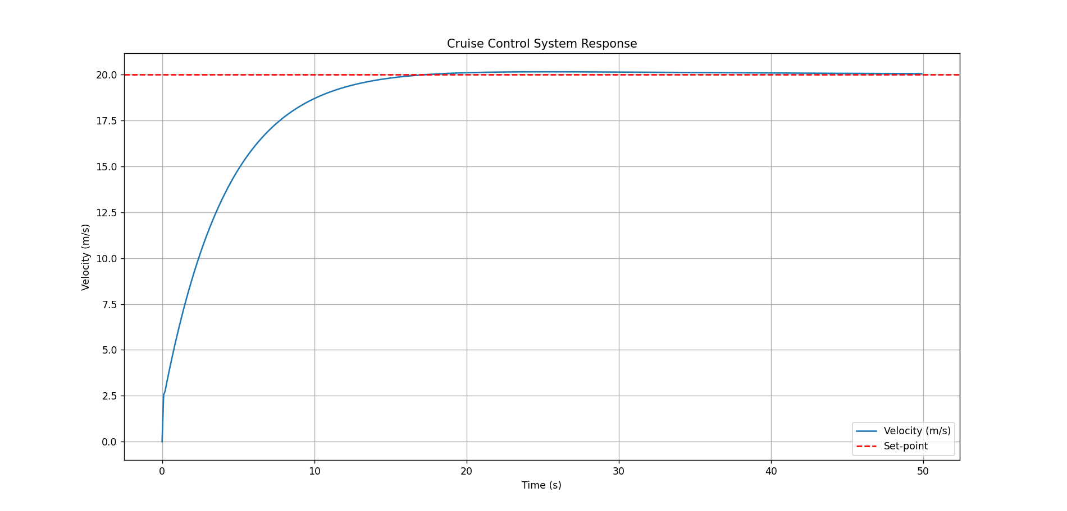 *The graph plotted:*